Singing Through the Heart of Winter:

Bringing Forth The Gift

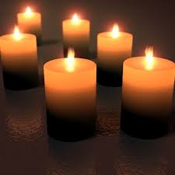

A weekend for men and women
December 11-13, 2015
Led by Doug von Koss and Richard Naegle

Full of singing, poetry, story, ritual, silence, community and love, this weekend is a preparation time for the Solstice season in the quiet and beauty of the redwoods. Just when our culture is speeding up for the ‘holidays,” our souls long for the “holy days,” to hold true to the heartbeat of nature—the rhythm of stillness, waiting, letting go, anticipation.
The darkness around us is deep…The potential birth of new light for us, our communities, and our world requires that we sacrifice old ways of being; that we bring forth new gifts worthy of a new year. What must you let go of? What must you risk bringing forth?

“Something has been calling to you
For longer than you can remember.
Calling to you to step out into the light, into your life.
It doesn’t matter whether you’re ready or not.”
Larry Robinson, “Roll Away the Stone”

Come, join with kindred spirits as we share good food and company, sing universal chants and songs in joyous harmony, celebrate tears and laughter, and explore Soul’s longing in the darkest night. Together, let us once again sing the world into being.
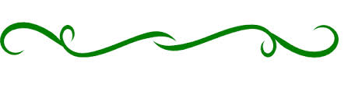
~St. Dorothy’s Rest, Camp Meeker~
(A lovely retreat center built in 1900 in a grove of redwoods,
an hour and half drive from the Bay Area.
Friday 8:00 pm, December 11
Through 11:30 am, Sunday December 13

Fee: $210/per person double occupancy (+ $20 for single)
Fee includes lodging, 4 meals, tuition and materials.
Event sponsored by the Redwood Men’s Center.

Register now, as attendance is limited.
To register, send your check (made out to the Redwood Men’s Center along with the following information: Name, email address, street address, telephone number and food preference (vegetarian or non-vegetarian). Mail to Richard Naegle, 7365 Johnson Lane, Forestville, CA 95436. For further information, contact Richard Naegle at richardnaegle@sbcglobal.net, or call 707-887-1985. You will receive more information and driving directions with your acceptance letter.
Please note that Richard will be out of the country 9/13-10/15; he will respond to your inquiries and confirm registrations when he returns.

